**C PROGRAMMING GITHUB DOCUMENT:**

1)DISPLAY INPUT (SIMPLE PROGRAM):

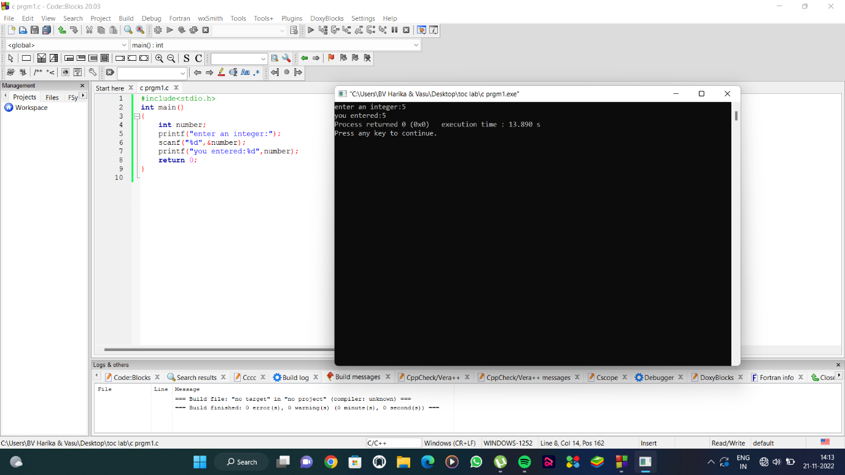

2)SUM OF INTEGERS:

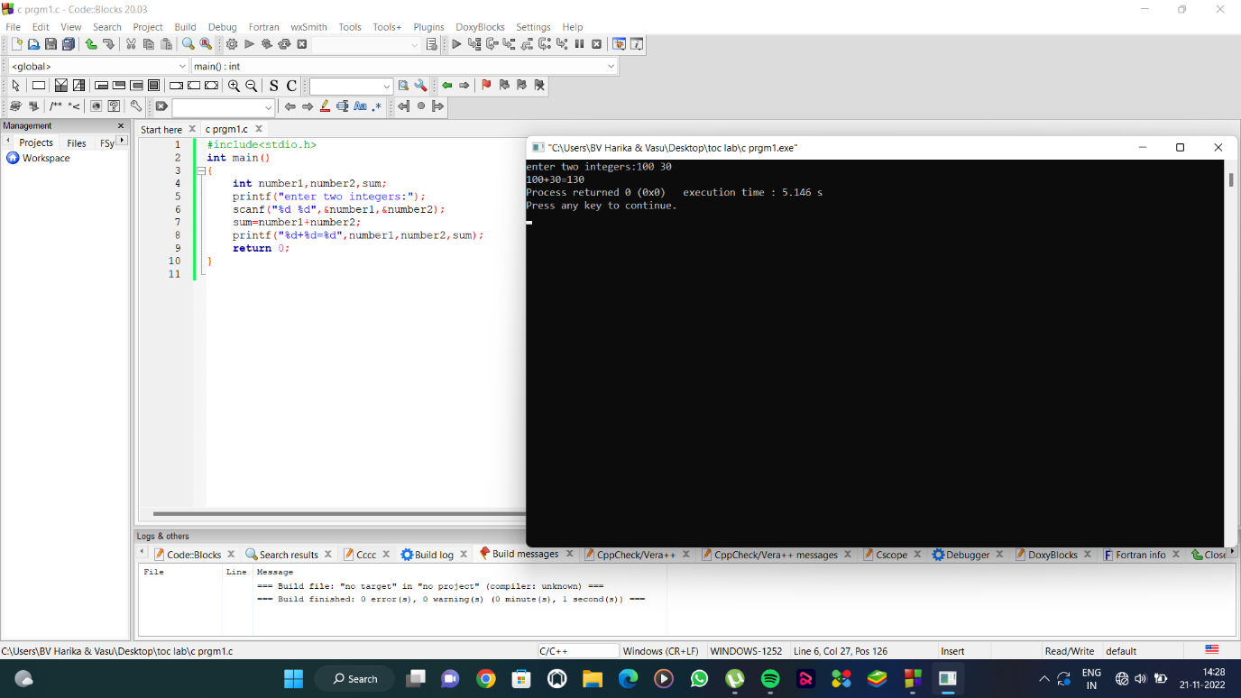

3)MULTIPLICATION OF INTEGERS:

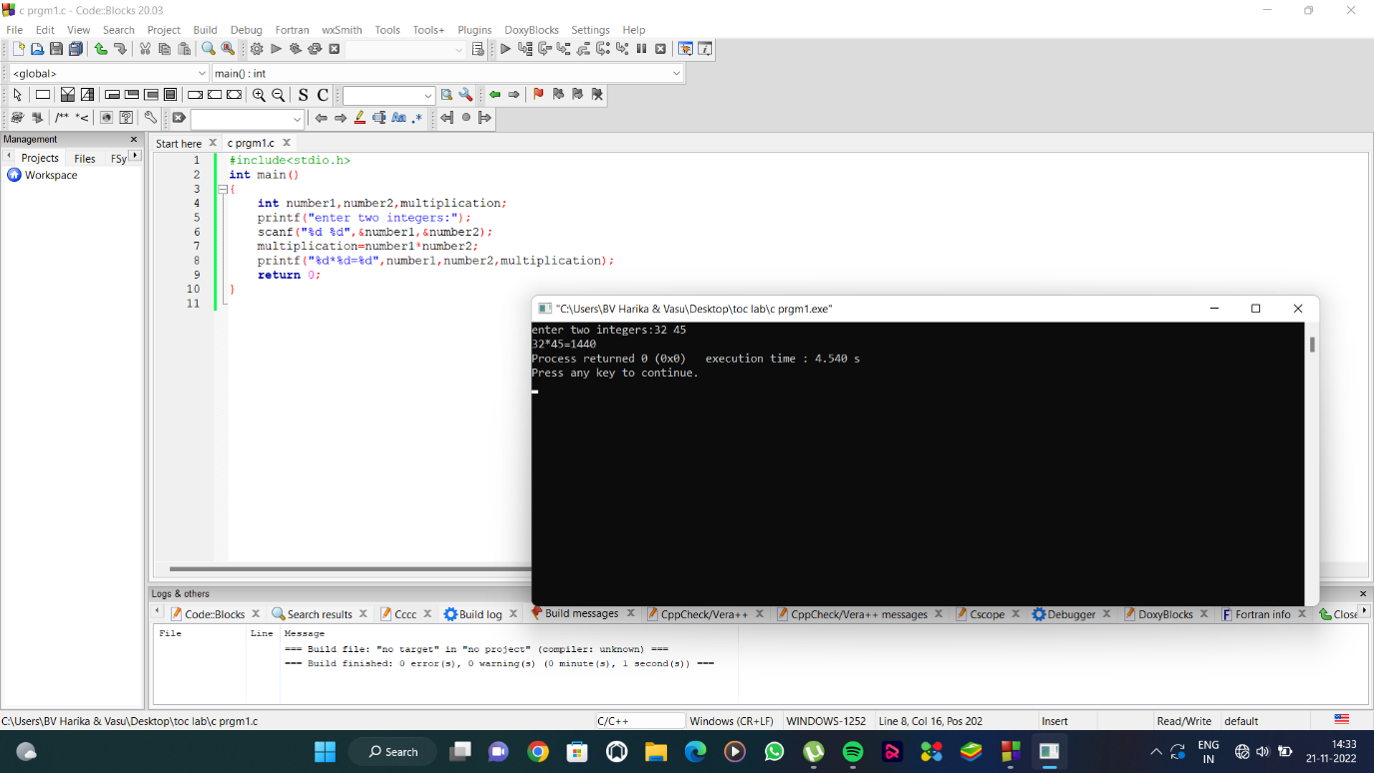

4)TO COMPARE BETWEEN TWO INTEGERS(MAX VALUE):

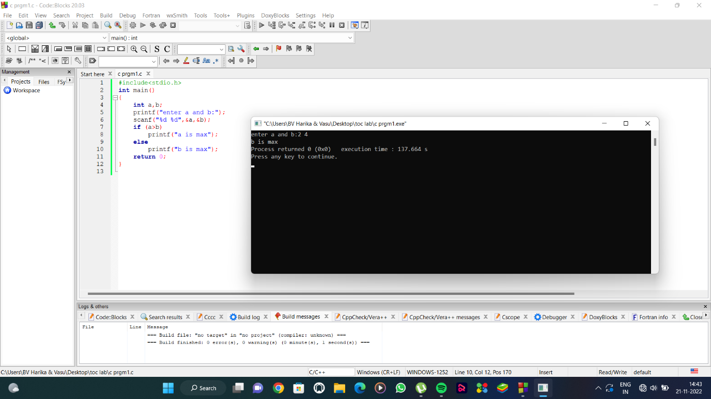

5)LIBRARY FUNTION SIMPLE EXAMPLE:

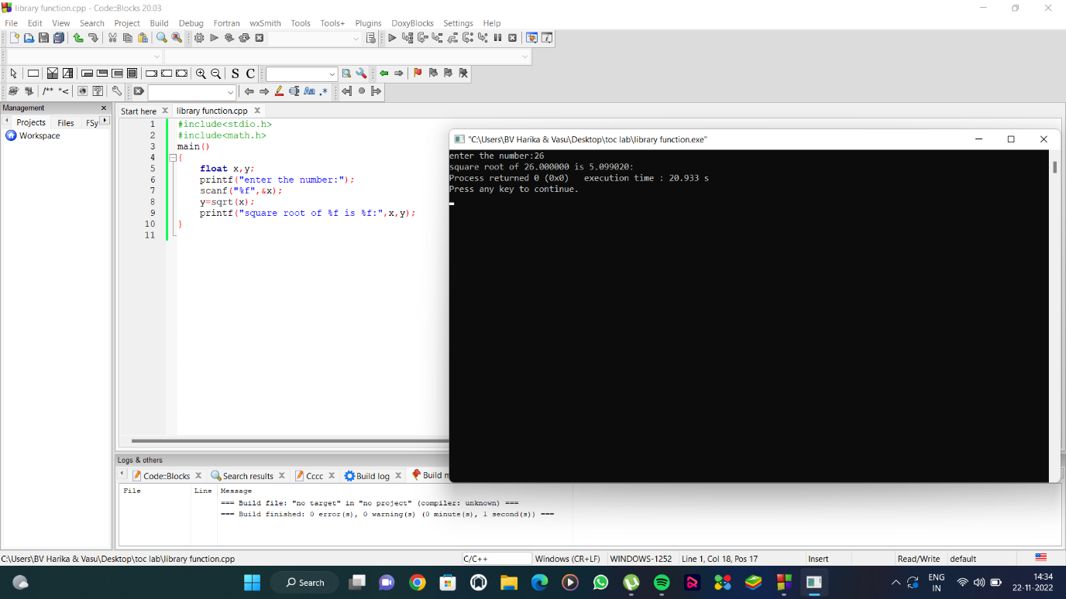

6)USER DEFINED FUNCTION:

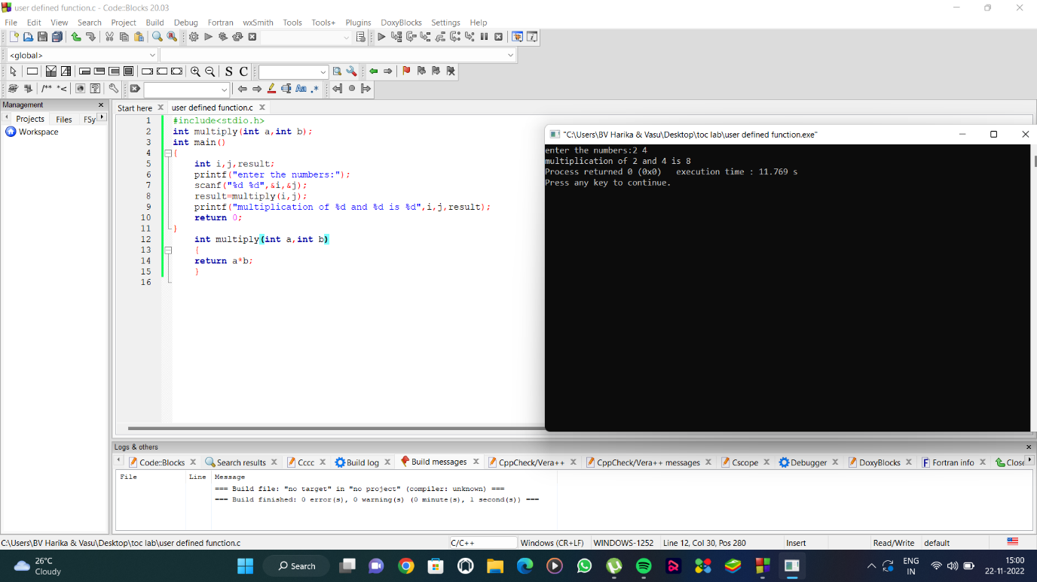

7)SQUARE ROOTS IN FLOATS:



8)INCREMENTS AND DECREMENTS OF INTEGERS:

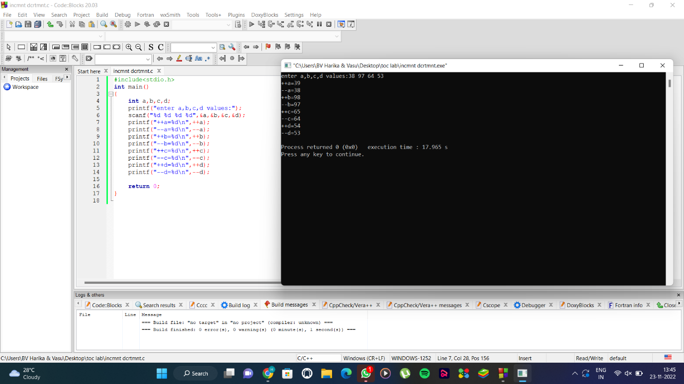

9)POINTERS:

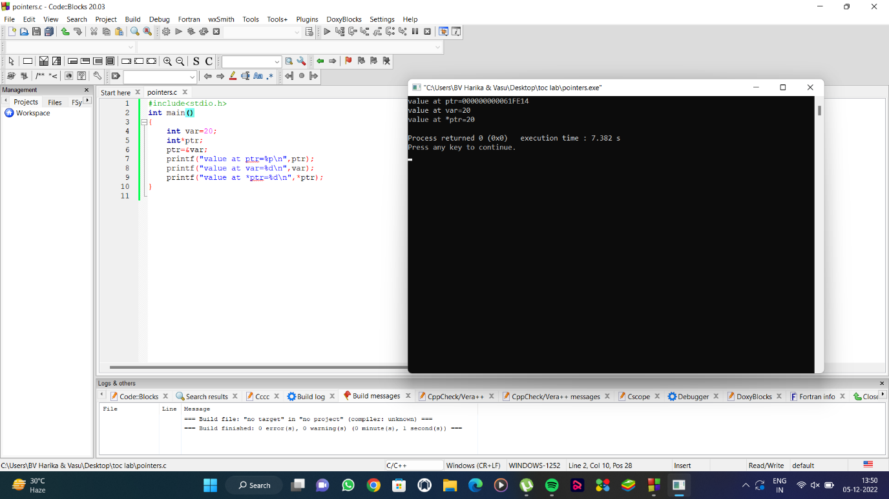

10)CALL BY VALUE:

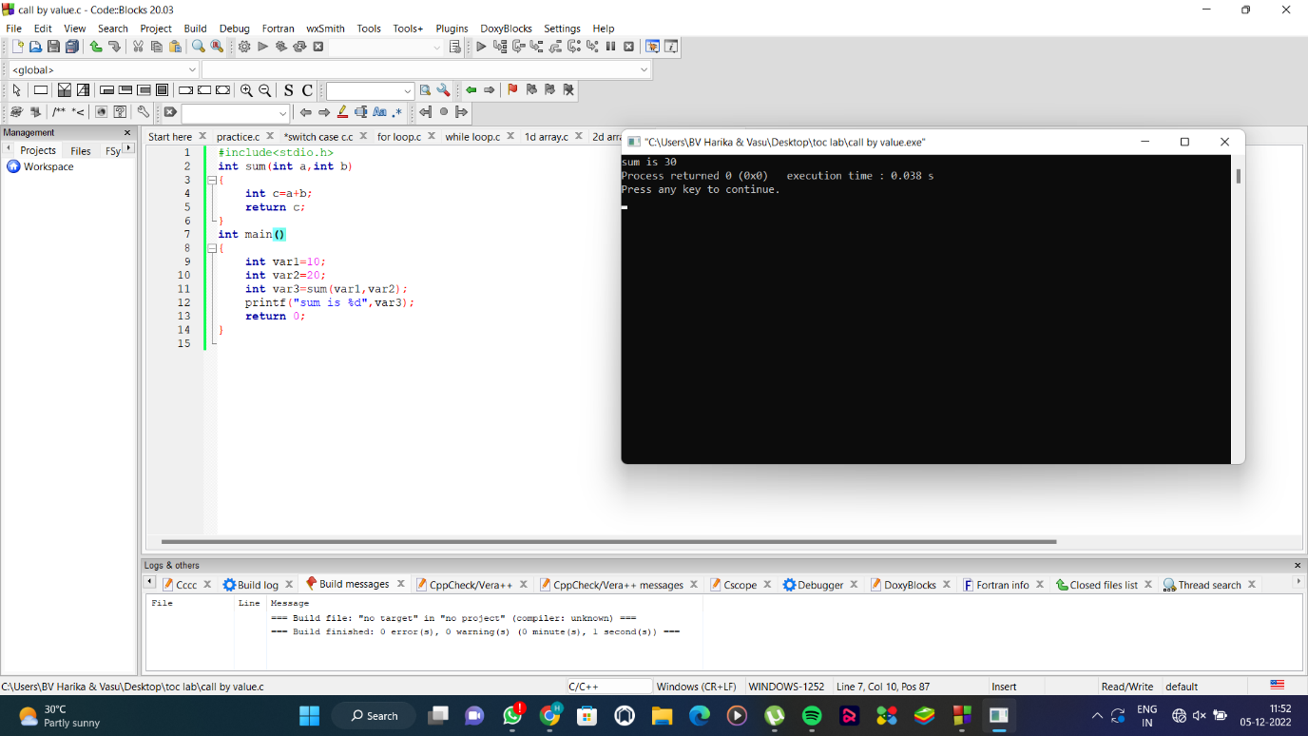

11)2D ARRAY:

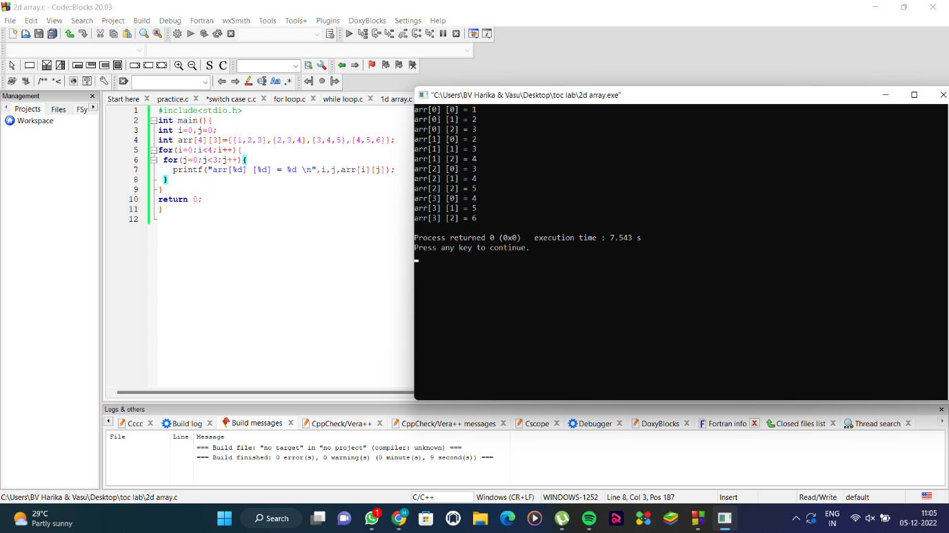

12)1D ARRAY

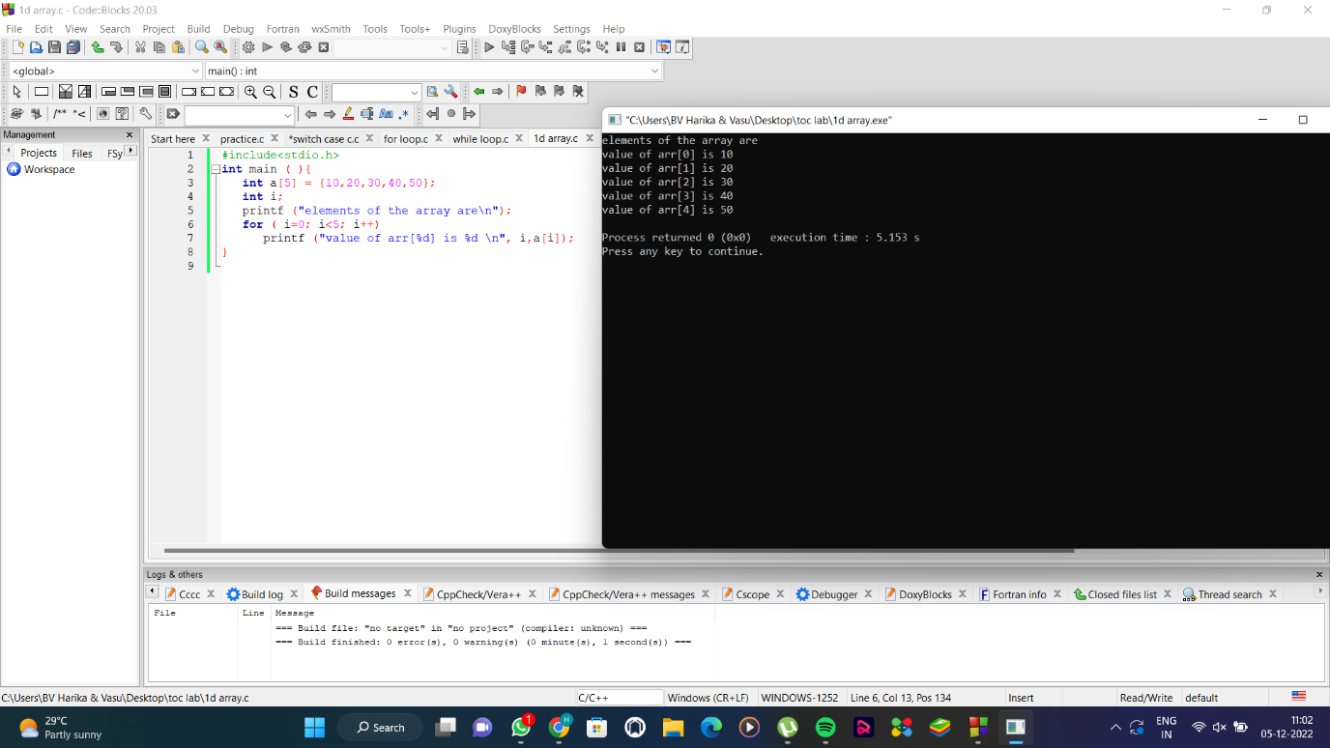

13)WHILE LOOP:

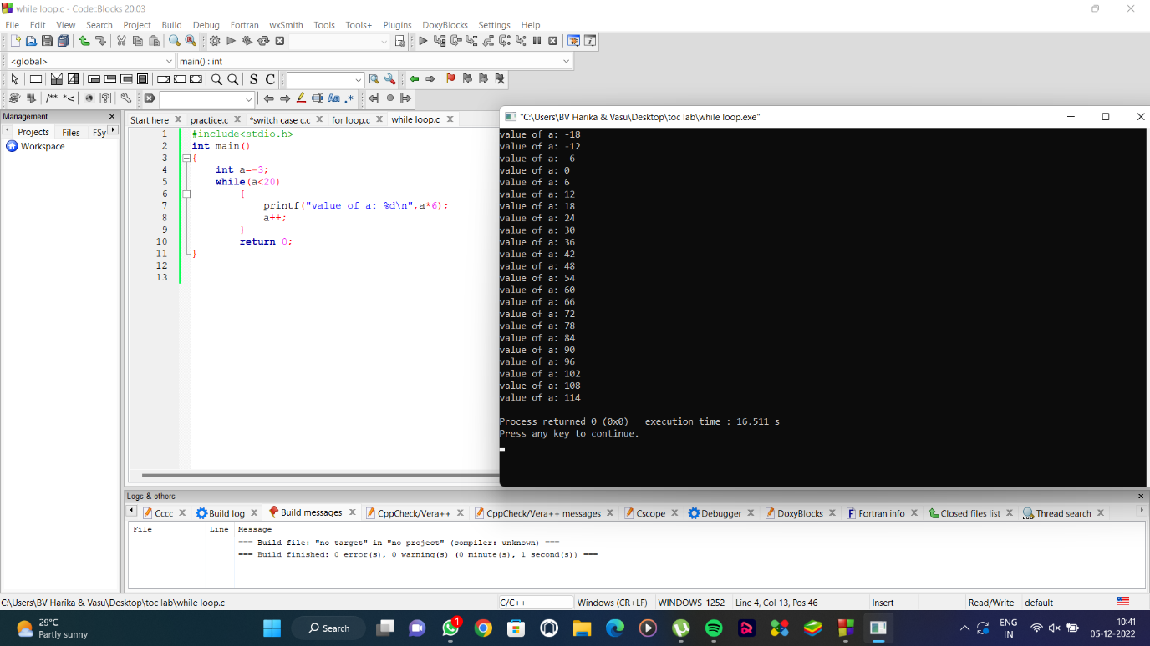

14)BREAK KEYWORD:

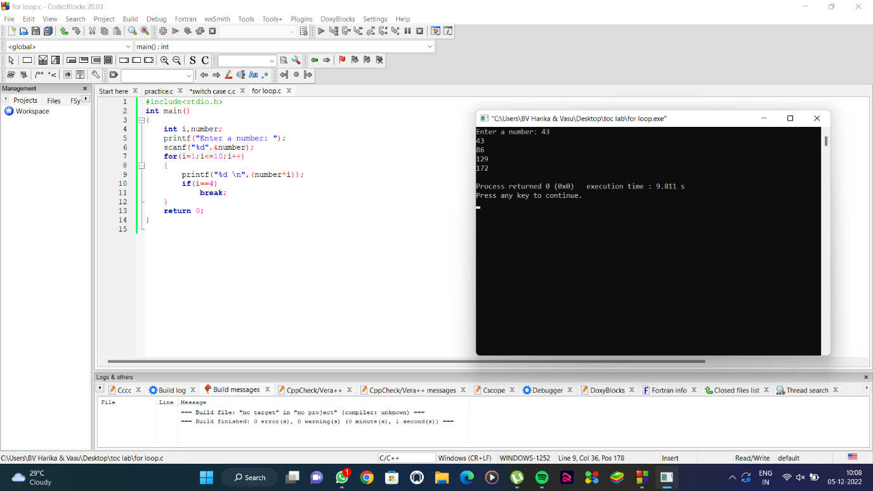

15)SWITCH CASE:

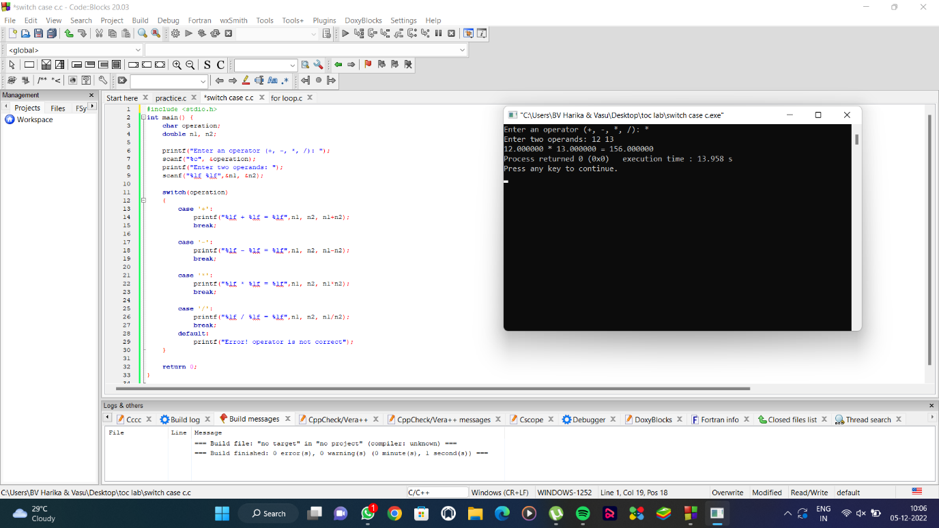

16)FOR LOOP:

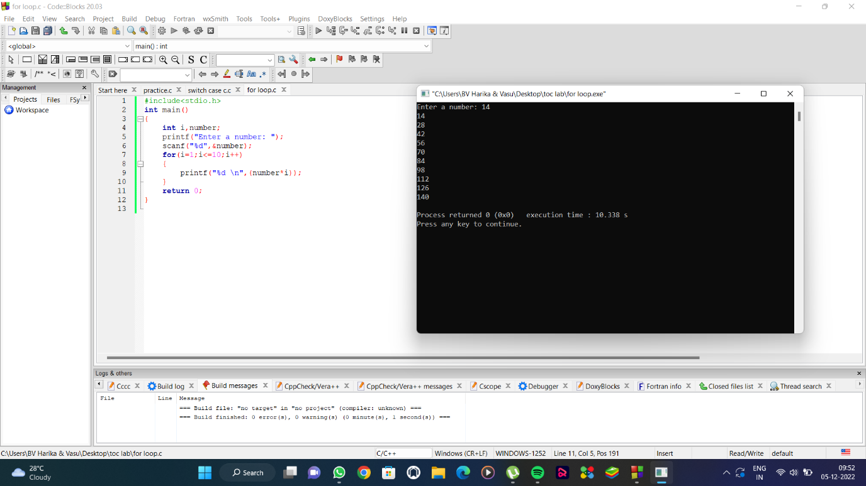

17)ELSE IF PROGRAM:

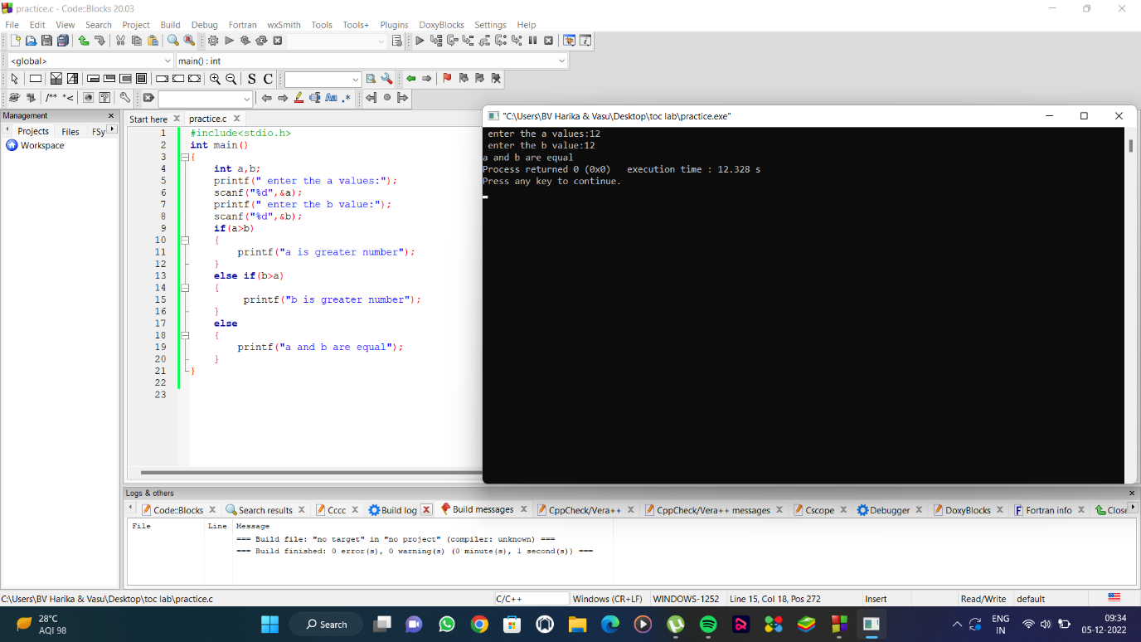

18)STRUCTURE IN C:

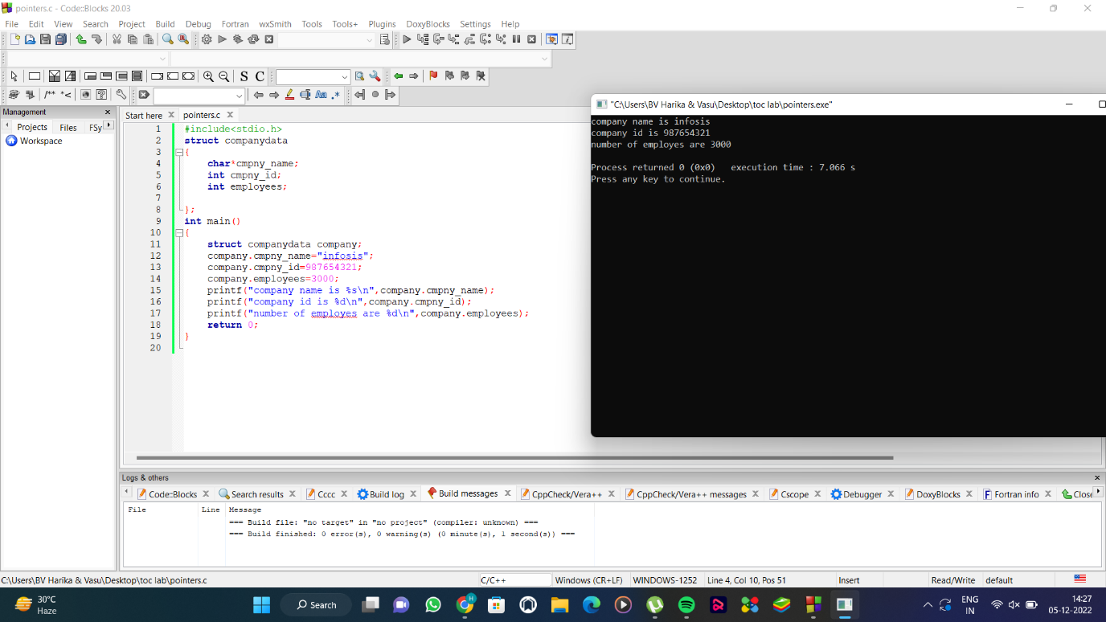

19)SIZE OF STRUCTURE:

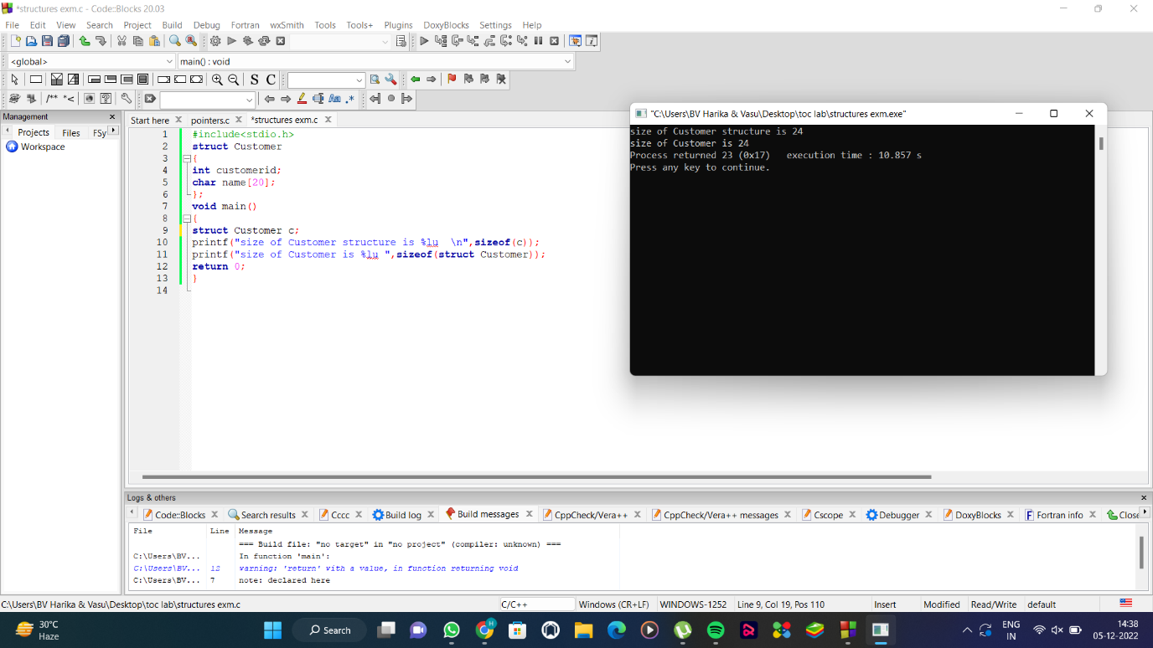

20)SIZE OF VARIABLES:

